Task 1: Create a Git Repository
Step 1: Create GitHub Account
- Open https://github.com
- Click Sign Up
- Enter:
  - Email
  - Password
  - Username
- Verify your email and login.
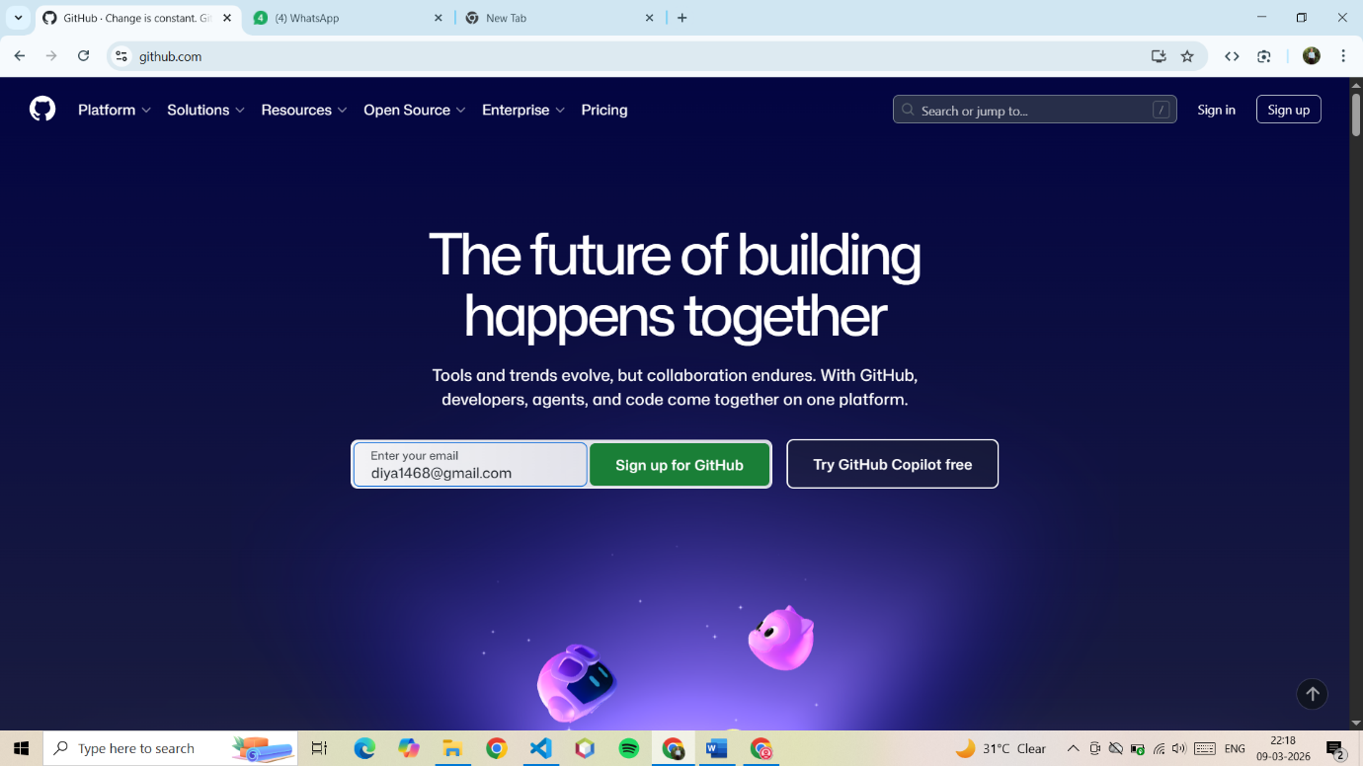

Step 2: Create Repository
- Click New Repository
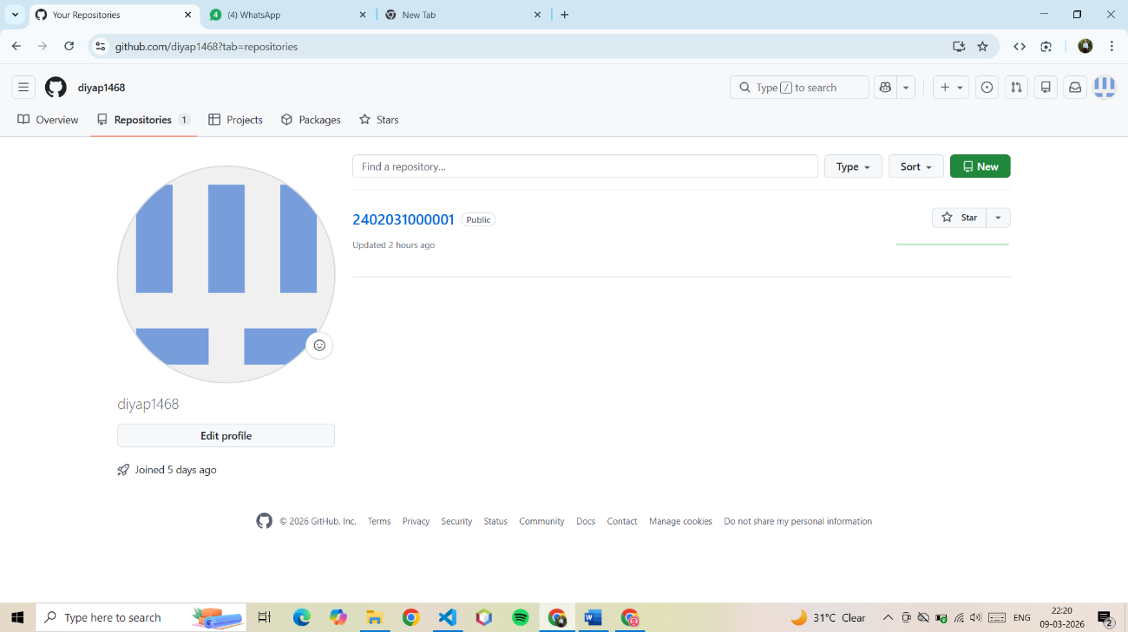
- In Repository Name, write your Enrollment Number
Example
Repository Name: 23012304001
- Select Public
- Click Create Repository
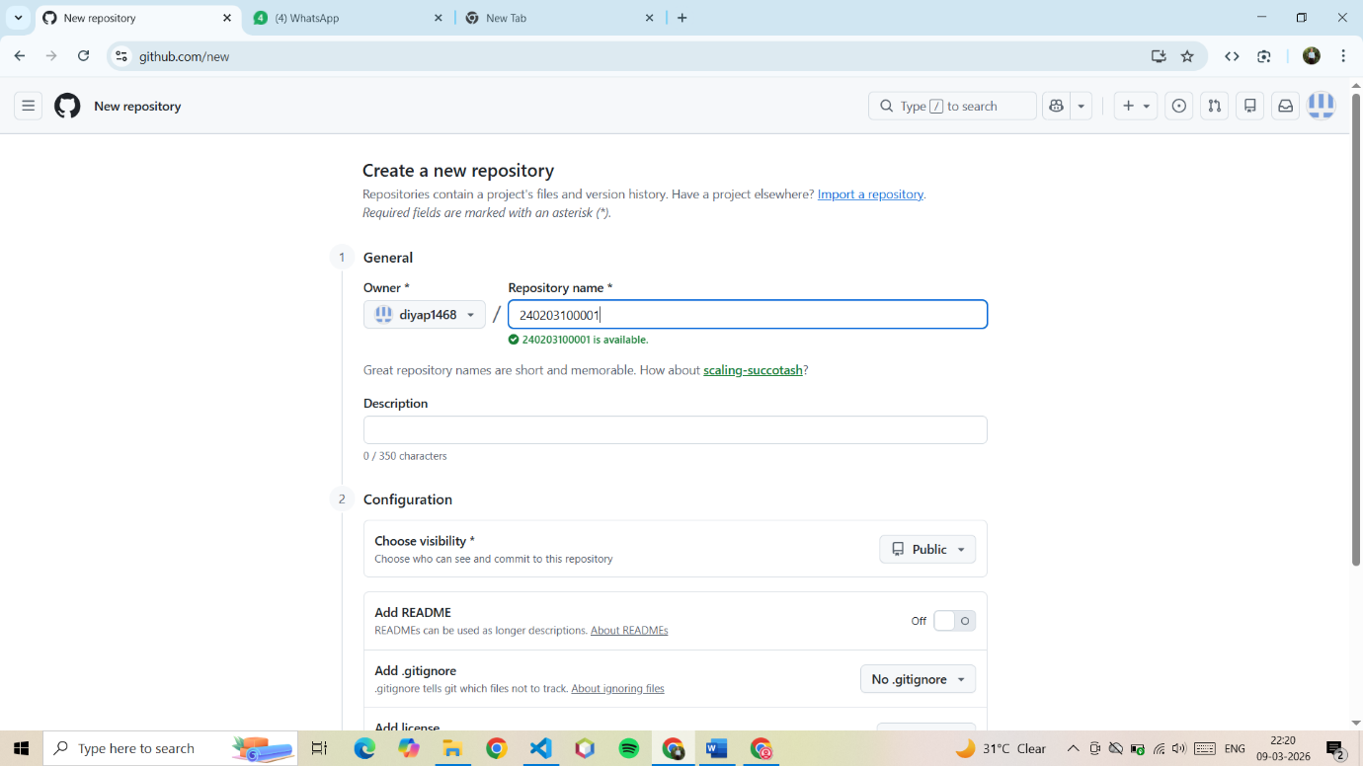

Step 3: Create Two Folders
Inside repository create folders:
Assignment_1
Assignment_2
Steps:
- Click Add File
- Select Create new file
- Type:
Assignment_1/README.md
- Click Commit Changes

Repeat same for:
Assignment_2/README.md
Now your repository structure will look like:
EnrollmentNumber
│
├── Assignment_1
│ └── README.md
│
└── Assignment_2
└── README.md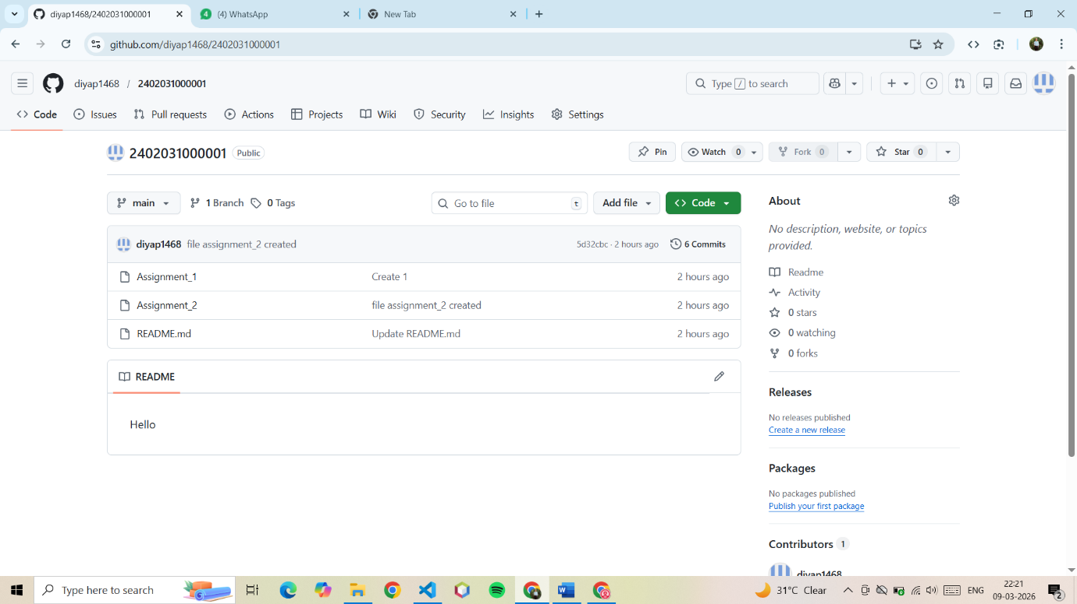

Step 4: Upload Files in Folder
- Open Assignment_1
- Click Upload Files
- Upload your Figma prototype screenshots
Repeat same for Assignment_2

Step 5: Copy Repository Link
Example:
https://github.com/yourusername/23012304001
Submit this link in Google Form.

